

[Training management sys-TMS]

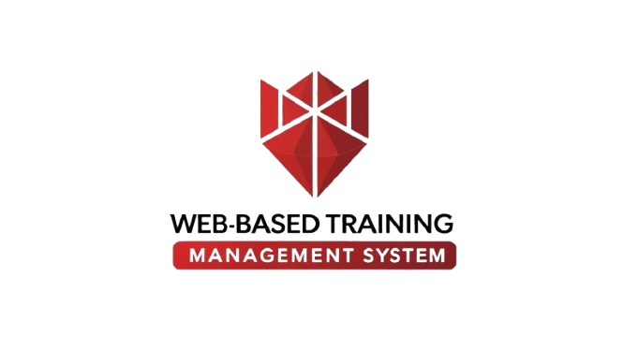 **A project dissertation by:**

**[ Leader: Amen Haitham ]**

**[CO Leader: Youssef Ibrahim]**

**[ Malak AbdulAziz Elrayes]**

**[ Hana Sayed Mohamed]**

**[ Mohamed khaled]**

**Supervised by:**

**[ En. Mohamed Hassan]**

**June 2025**





Training management sys-TMS

ACKNOWLEDGEMENT

No one can achieve his goal alone we all live in a world where we need the

help of each other to achieve our goals.

This moment is one of our most valuable, remarkable, and important

moments. We want to thank everyone who helped us

to get that project done. First, we would like to thank our professor

**En. Mohamed Hassan** was always there when we needed him the most. We want

to thank him for encouraging us throughout the way till this moment he gives us

hope to carry on. It was such an honor to work under his supervision. Then

we are very grateful to our families for their support, encouragement.

Table of Contents

**Training management sys-TMS ..........................................................................1**

**Chapter 1……………………………………………………………………………………..2**

**1.2 Objectives:2.......................................................................**

**Introduction:.......................................................................................3**

**1.1Overview:..........................................................................................4**

**Key Features:4............................................................................................1.2 Purpose:.............................................................................................51.3 Scope:.**.......................................................................................................**6**

**Chapter 2………………………………………………………………..............................…**8

**Planning and Analysis…………………………...............…………………..............**.9

**2.1 Project Planning:..............................................................................1**0

**2.1.1 Feasibility Study:..............................................................................**11

**2.3 Analysis of the system:.......................................................................**12

**2.3.1 User Requirements:**.............................................................................13

**2.4 Advantages of the system:..................................................................**14

**Chapter 3:................................................................................................**18

**2.7 User stories:.......................................................................................**17

**3.1 Schema:.............................................................................................2**0

**3.3 Ui / Ux:.............................................................21**

**3.4TestCase:...........................................................................................2**2**...**



**Chapter 1**

**Introduction**

**1.**1**Introduction:**

****In today’s rapidly evolving business landscape, employee training is a cornerstone of success.**** A ****Training Management System (TMS)**** empowers organizations to efficiently organize and manage training programs, ensuring employees acquire the skills they need to thrive. By streamlining training processes, a TMS enhances learning effectiveness, drives performance improvement, and boosts overall productivity.

**With a **Training Management System**, companies can:**

****Save time and resources**** by automating routine tasks such as enrollment, attendance tracking, and reporting.

****Enhance communication**** between trainers, trainees, and administrators through smart notifications and reminders.

****Measure training effectiveness**** with performance analytics and trainee feedback, enabling continuous program optimization.

****Ensure transparency and credibility**** by automatically generating verifiable completion certificates.

In short, a ****TMS is a strategic tool**** that aligns with modern workplace demands, maximizing the return on training investments and delivering measurable value to both organizations and employees.

**1.**2**Overview:**

The ****Training Management System (TMS)**** is a web-based application designed to streamline and automate employee training programs. It serves three primary user roles: ****Admin****, ****Trainer****, and ****Trainee****, each with distinct responsibilities and functionalities. The system aims to enhance training efficiency, improve coordination, and track employee progress through features like course management, attendance tracking, automated notifications, and certificate generation.

**1.**3**Key Features :**

* ****User Authentication****: Secure login with role-based access control.
* ****Course Management****: Create, modify, and assign courses.
* ****Session Management****: Schedule sessions, send reminders, and record attendance.
* ****Feedback and Reports****: Collect trainee feedback and generate performance reports.
* ****Certificate Generation****: Automatically issue certificates upon course completion.

**1.**4 **Objectives:**

The ****Training Management System (TMS)**** is designed to achieve the following key objectives:

1. ****Streamline Training Program Management****

* Provide a centralized platform for end-to-end training administration
* Reduce administrative complexities associated with training operations

1. ****Enhance Stakeholder Coordination****

* Facilitate effective communication between administrators, trainers, and trainees
* Ensure clear definition of roles and responsibilities

1. ****Improve Progress Tracking & Performance Monitoring****

* Offer tools to track trainee attendance and evaluate performance
* Generate periodic reports to measure training effectiveness

1. ****Increase Efficiency Through Automation****

* Automate repetitive tasks (scheduling, reminders, certification)
* Minimize human errors and improve data accuracy

1. ****Ensure Training Quality & Continuous Improvement****

* Collect trainee feedback to assess and enhance program quality
* Regularly update training content to meet evolving needs

1. ****Boost Trainee Engagement & Motivatio****

* Deliver user-friendly and engaging learning experiences
* Provide certified completion certificates as achievement rewards

**1.**5**Purpose:**

The ****Training Management System (TMS)**** is specifically designed to ****streamline and optimize employee training programs**** by providing a ****comprehensive digital solution**** that addresses all aspects of training management. The system aims to:

1. ****Enhance Training Efficiency****

Automate administrative tasks such as enrollment, scheduling, and attendance tracking.

Reduce manual workload and eliminate redundancies in training coordination.

1. ****Improve Learning Outcomes****

Provide employees with ****easy access**** to training materials, progress tracking, and performance assessments.

Enable ****personalized learning paths**** to cater to individual skill development needs.

1. ****Ensure Consistency & Compliance****

Standardize training content and evaluation methods across the organization.

Automate certification and record-keeping for ****audit and compliance purposes****.

1. ****Facilitate Data-Driven Decisions****

Generate ****real-time reports and analytics**** on training effectiveness, participation, and skill gaps.

Help HR and management ****measure ROI**** and adjust training strategies accordingly.

1. ****Boost Engagement & Accessibility****

Offer ****mobile-friendly access**** for learning anytime, anywhere.

Incorporate interactive features (quizzes, feedback tools) to enhance trainee engagement.

**1.**6**Scope:**

The ****Training Management System (TMS)**** is a web-based application designed to streamline and automate employee training programs. It serves three primary user roles: ****Admin****, ****Trainer****, and ****Trainee****, each with distinct responsibilities and functionalities. The system aims to enhance training efficiency, improve coordination, and track employee progress through features like course management, attendance tracking, automated notifications, and certificate generation.



**Chapter 2**

**Planning and Analysis**

**2.1 Project Planning:**

**2.1.1 Feasibility Study:**

**• Technical Feasibility**

Project ****Training Management System (TMS)**** is a web. The main technologies and tools that are associated with **Training Management System (TMS)** are

• HTML

• Java Script

• PostgreSql

• Css

• Java

**• Social/Legal Feasibility**

**Training Management System (TMS)** uses freely available development tools and provides the service for everyone. Software libraries that are used in this system are free open-source libraries.

**2.**2 **Analysis of the system:**

**2.**2**.1 Training Requirements:**

The training requirements ensure smooth course delivery, trainee engagement, and performance tracking. They cover scheduling, materials, attendance, assessments, feedback, and certification to create an effective learning experience.

**2.**2**.2 Admin Requirements:**

The Admin ensures the system runs smoothly by managing users, courses, schedules, attendance, feedback, and security. Their role is critical for maintaining an efficient and effective training process.

**2.2.3 Trainer Requirements:**

1. Trainers must have a personal account with secure login access.
2. Upon logging in, trainers should see a dashboard showing:
3. Assigned training courses
4. Upcoming training sessions with dates and times
5. Notifications or announcements from the admin or trainees
6. Ability to upload training materials (e.g., files, videos, links)
7. Ability to track and record trainee attendance
8. Capability to evaluate trainees and provide feedback or grades
9. Access to performance reports for trainees in their assigned courses
10. Communication tools to interact with trainees (e.g., internal messaging or comments)
11. Option to request session rescheduling or adjust session times (if permitted)
12. Access to trainee certificates for review or download

**2.2.4 Trainee Requirements:**

Trainees need an easy-to-use system that allows them to enroll, learn, track progress, communicate, and receive certifications efficiently. The system should support self-paced and scheduled learning while encouraging feedback.

**2.3 System Requirements:**

The Training Management System (TMS) relies on key requirements to run smoothly and provide great user experience. Here are the essential components needed for the system:

## User Authentication

* Secure Login: Users must create secure login accounts with password protection to safeguard personal data. Access requires a privilege code provided by an administrator.
* Role-Based Access Control: Different user roles (Admin, Trainer, Trainee) must have distinct permission levels that define the data and functionalities they can access.

**Training Management**

* Completed Trainings
* Creation and Modification: Administrators should have the ability to easily create, modify, and delete training.

## Course Management

* Creation and Modification: Administrators should have the ability to easily create, modify, and delete courses.
* Assign trainers to courses.

## Session Management

* Scheduling: The system needs a robust scheduling function that allows Admins to set time slots for live training sessions.
* Reminders: Automated email or notification reminders should be sent to Trainees before sessions to increase attendance rates.
* Record Keeping: Post-session, the system must store notes, materials, and attendance data for compliance and future reference

## Attendance Tracking

* Automated Attendance Recording: Attendance should be tracked automatically through check-in features or integration with tools like QR codes or geolocation,

**if this can't** **do we will use manual entry**.

* Reporting Tools: The system should generate reports that summarize attendance patterns, allowing Admins and Trainers to identify issues or trends in participation.
* Notifications for Absences: Alerts should inform relevant parties when trainees miss sessions, allowing for follow-up communications.

## Feedback and Reports

* Evaluation Tools: Trainees should be able to provide feedback on courses, allowing Trainers to assess the effectiveness and make necessary adjustments.

## Certificate Generation

* Automated Certificates: Upon successful completion of courses, the system should automatically generate and issue certificates to Trainees, which can be electronically signed.
* Downloadable Formats: Trainees should have the option to download their certificates in various formats (PDF, PNG) for easy distribution.

**2.4 Advantages of the system:**

The Training Management System streamlines operations, enhances learning experiences, and provides measurable benefits for both organizations and employees.



**Chapter 3**

**3.1 ERD:**

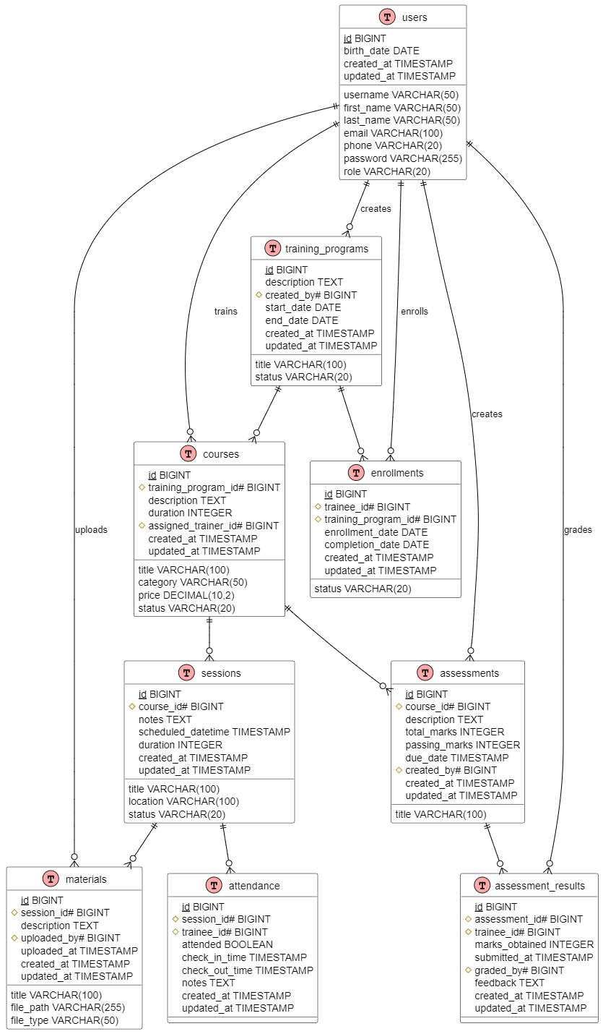

**3.1 Schema:**

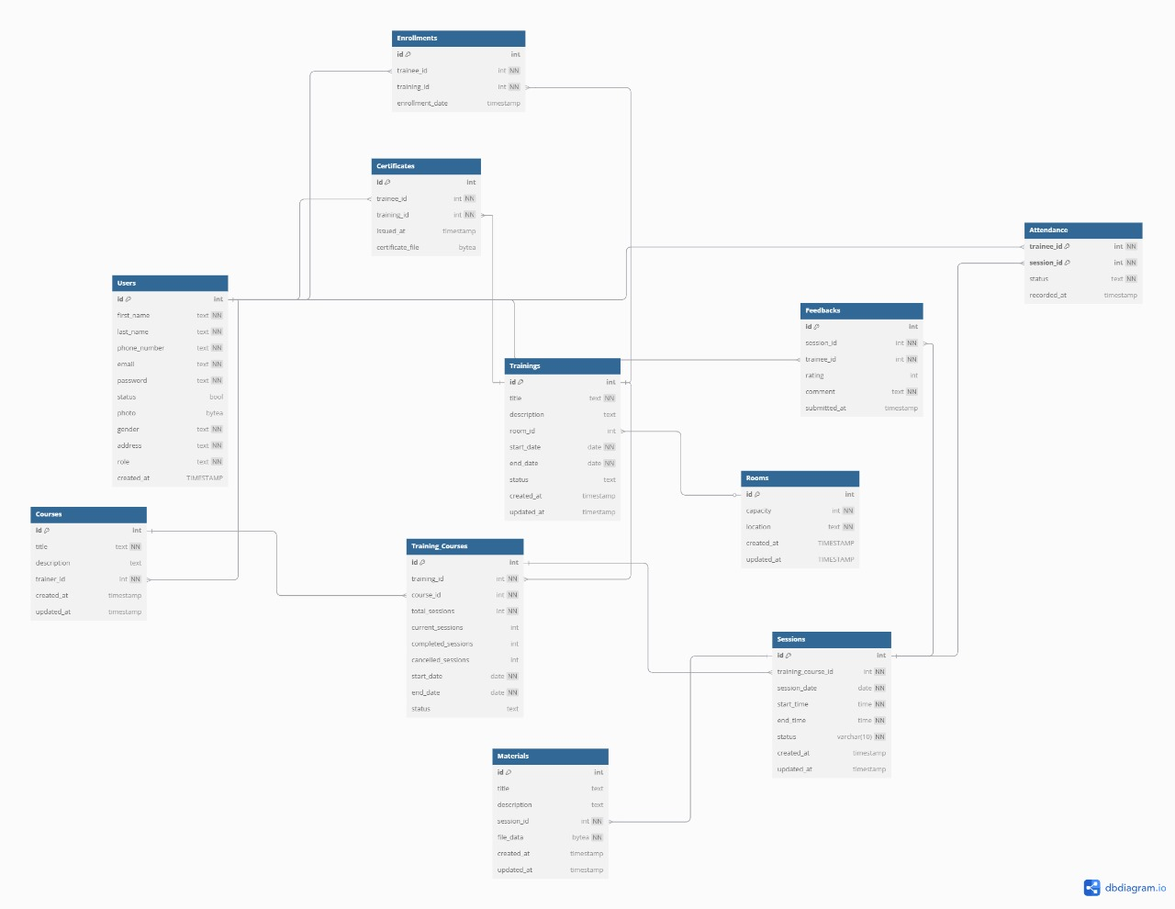

**3.2User stories:**

### Admin User Stories

* As an admin,

I want to create and manage training programs

so that Trainee can enroll in relevant courses.

* As an admin,

I want to edit existing training courses

so that I can update training materials and details.

* As an admin,

I want to schedule training sessions

so that trainees know when to attend.

* As an admin,

I want to track attendance

so that I can measure engagement.

* As an admin,

I want to assign trainers to courses

so that training sessions are effectively conducted.

* As an admin,

I want to view feedback reports

so that I can assess training effectiveness.

* As an admin,

I want to generate training certificates

so that I can recognize trainee achievements.

* As an admin,

I want to generate training reports

so that I can analyze outcomes.

### Trainer User Stories

* As a trainer,

I want to upload training materials

so that trainees can access relevant content.

* As a trainer,

I want to delete unnecessary or incorrect content

so that trainees receive only the most accurate information.

* As a trainer,

I want to provide feedback on trainees

so that I can help them improve.

* As a trainer,

I want to view my scheduled training sessions

so that I can manage my time effectively.

* As a trainer,

I want to create quizzes and assessments

so that I can evaluate trainees' knowledge.

### Trainee User Stories

* As a trainee,

I want to view my scheduled training sessions

so that I can manage my time effectively.

* As a trainee,

I want to access training materials

so that I can study at my own pace.

* As a trainee,

I want to provide feedback on a training course

so that I can share my learning experience.

* As a trainee,

I want to complete assessments

so that I can test my understanding of the course.

* As a trainee,

I want to download my training certificate

so that I can showcase my skills.

**3.4Test Cases:**



**3.5 Ui/Ux:**

**3.5.1 Login:**

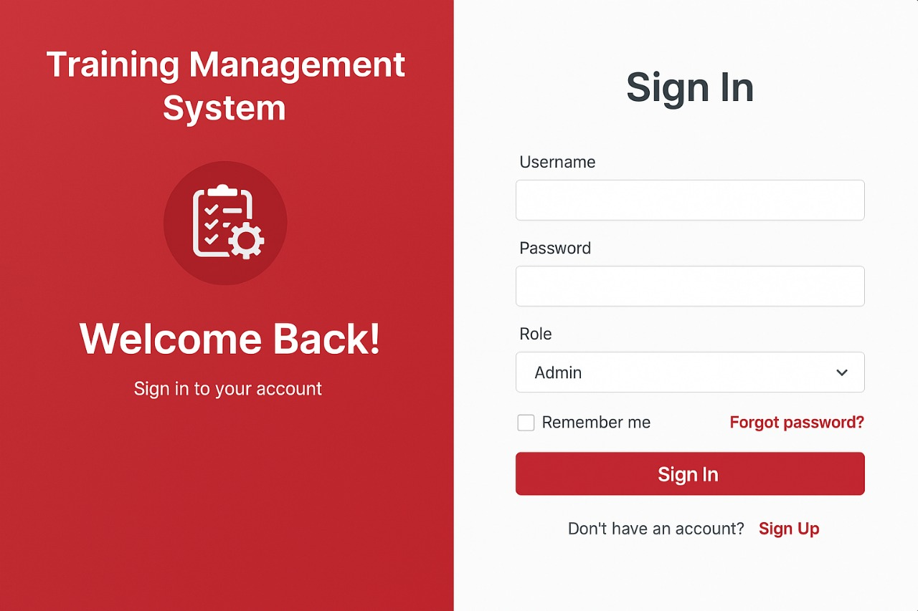

**3.5.2 Sign Up:**

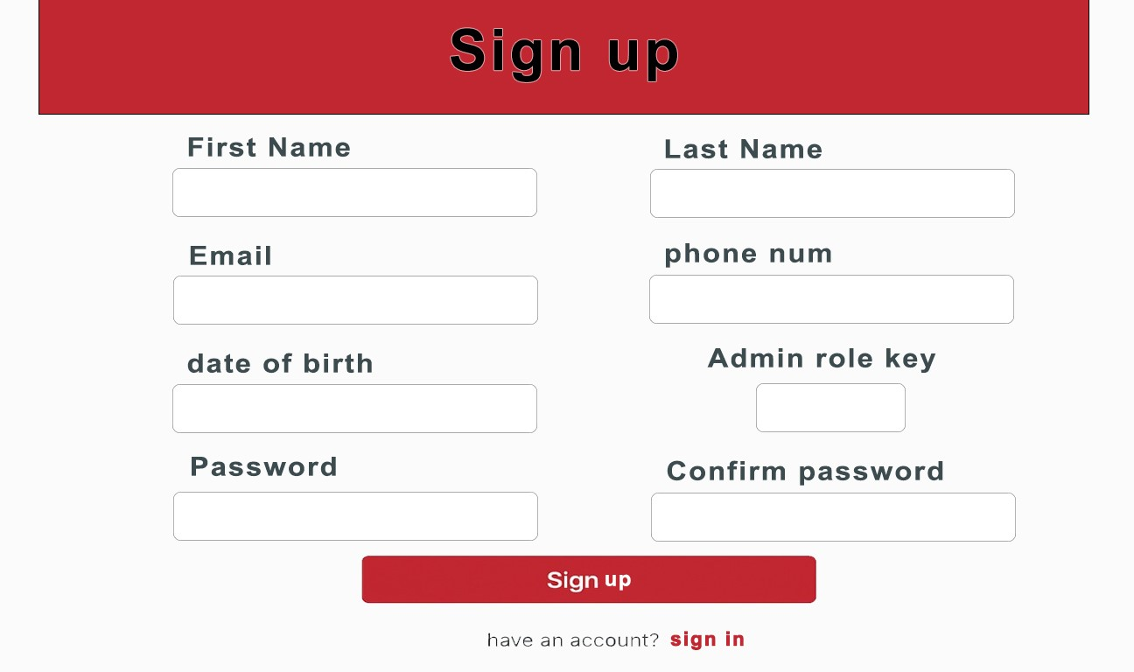

**3.5.3 Admin Dashboard:**

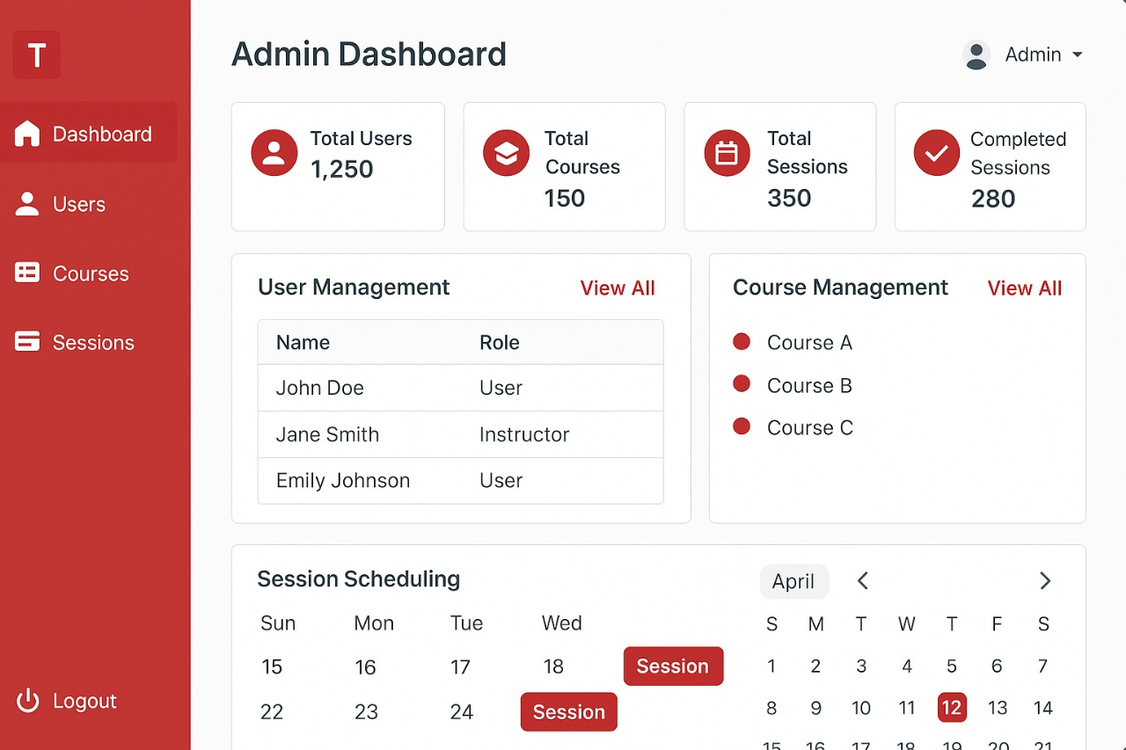

**3.5.4 User Management:**

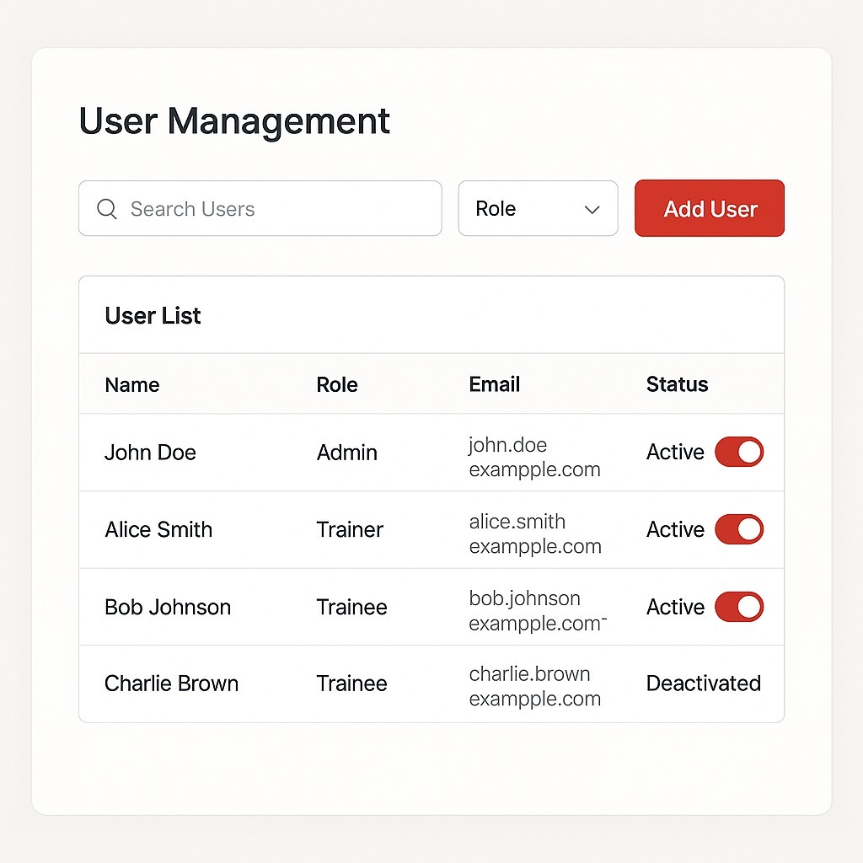

**3.5.5 Course Management:**

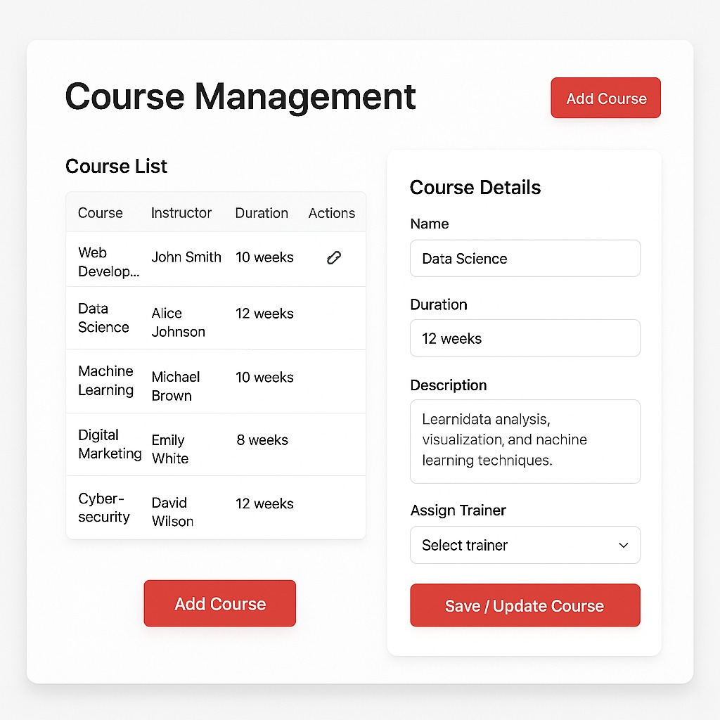

**3.5.6 Session Scheduling:**

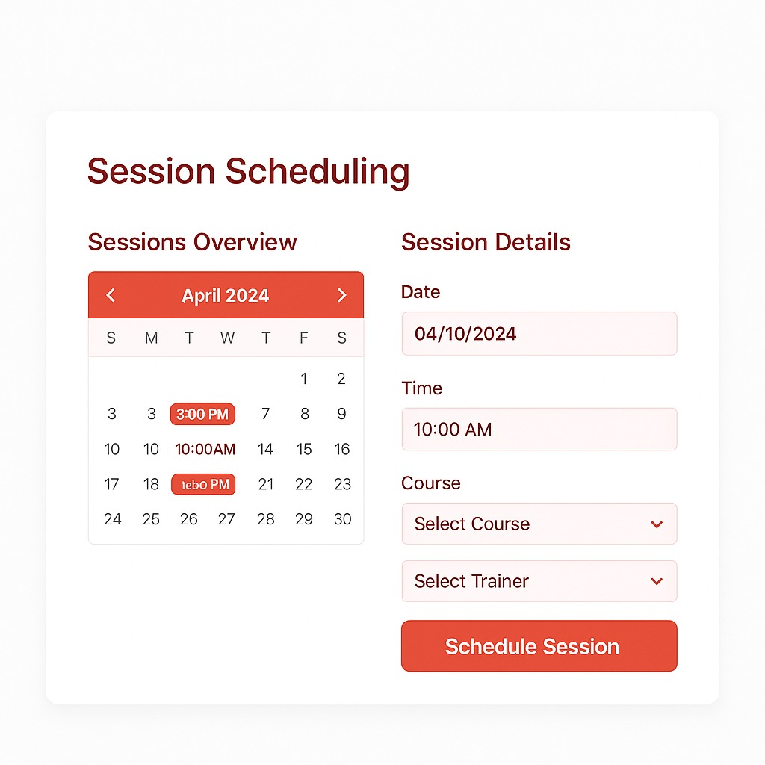

**3.5.7 Enrollment :**

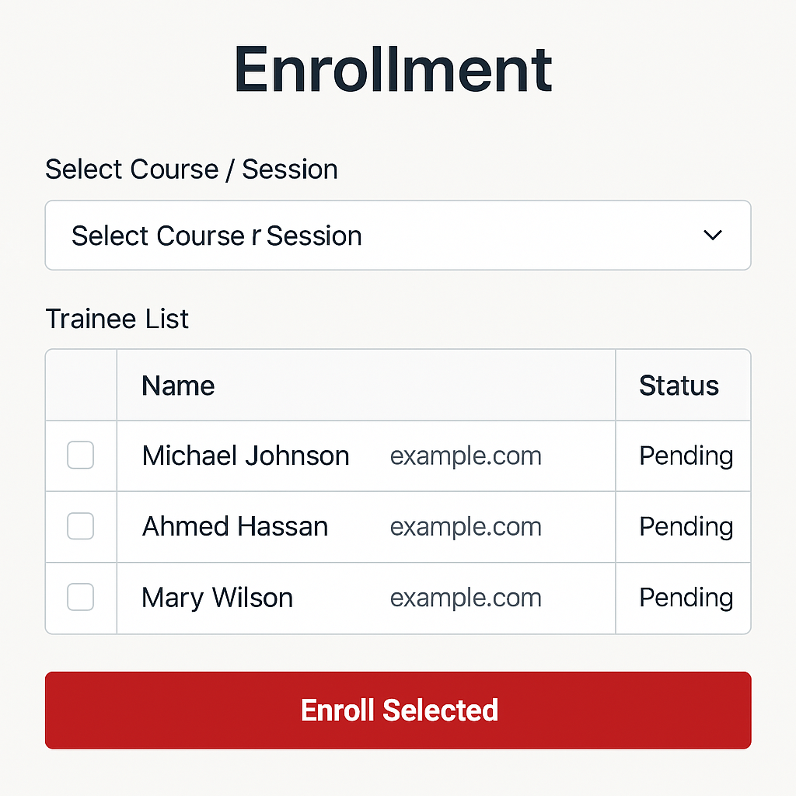

**3.5.8 Attendance Tracking :**

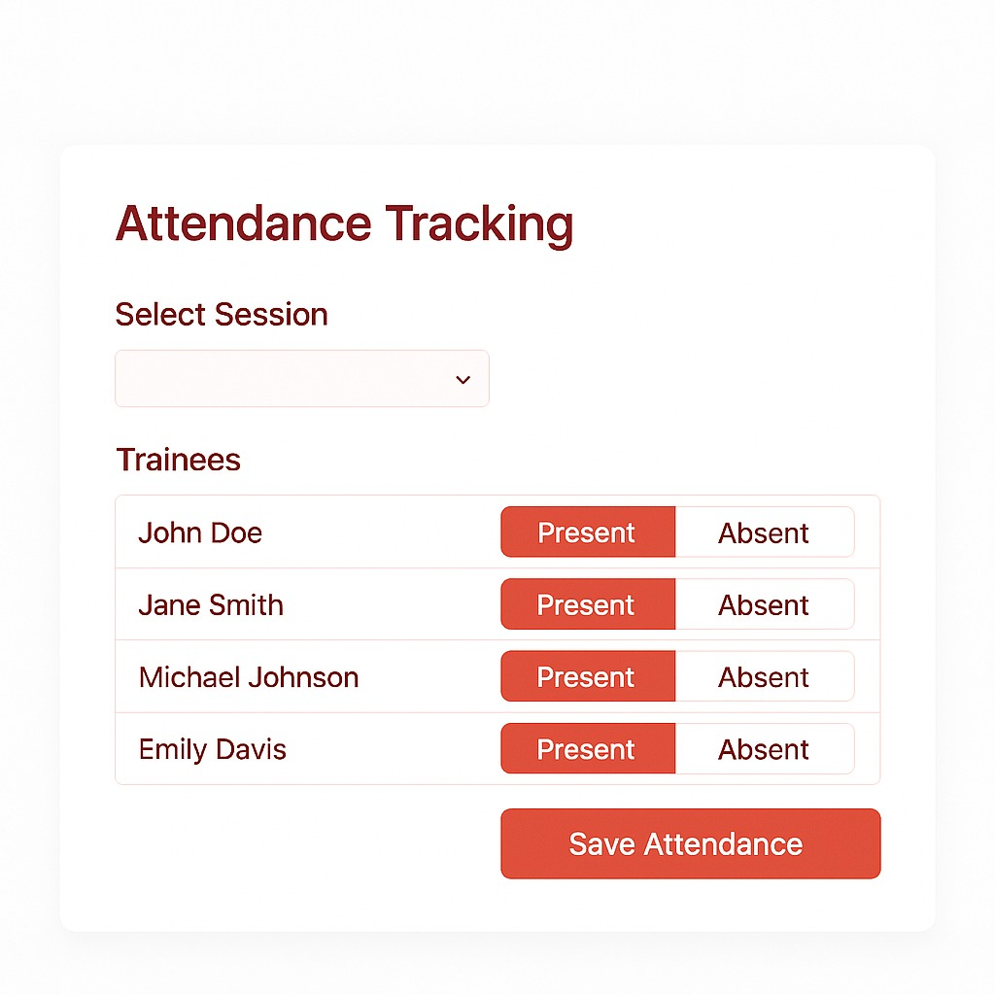

**3.5.9 Progress Tracking :**

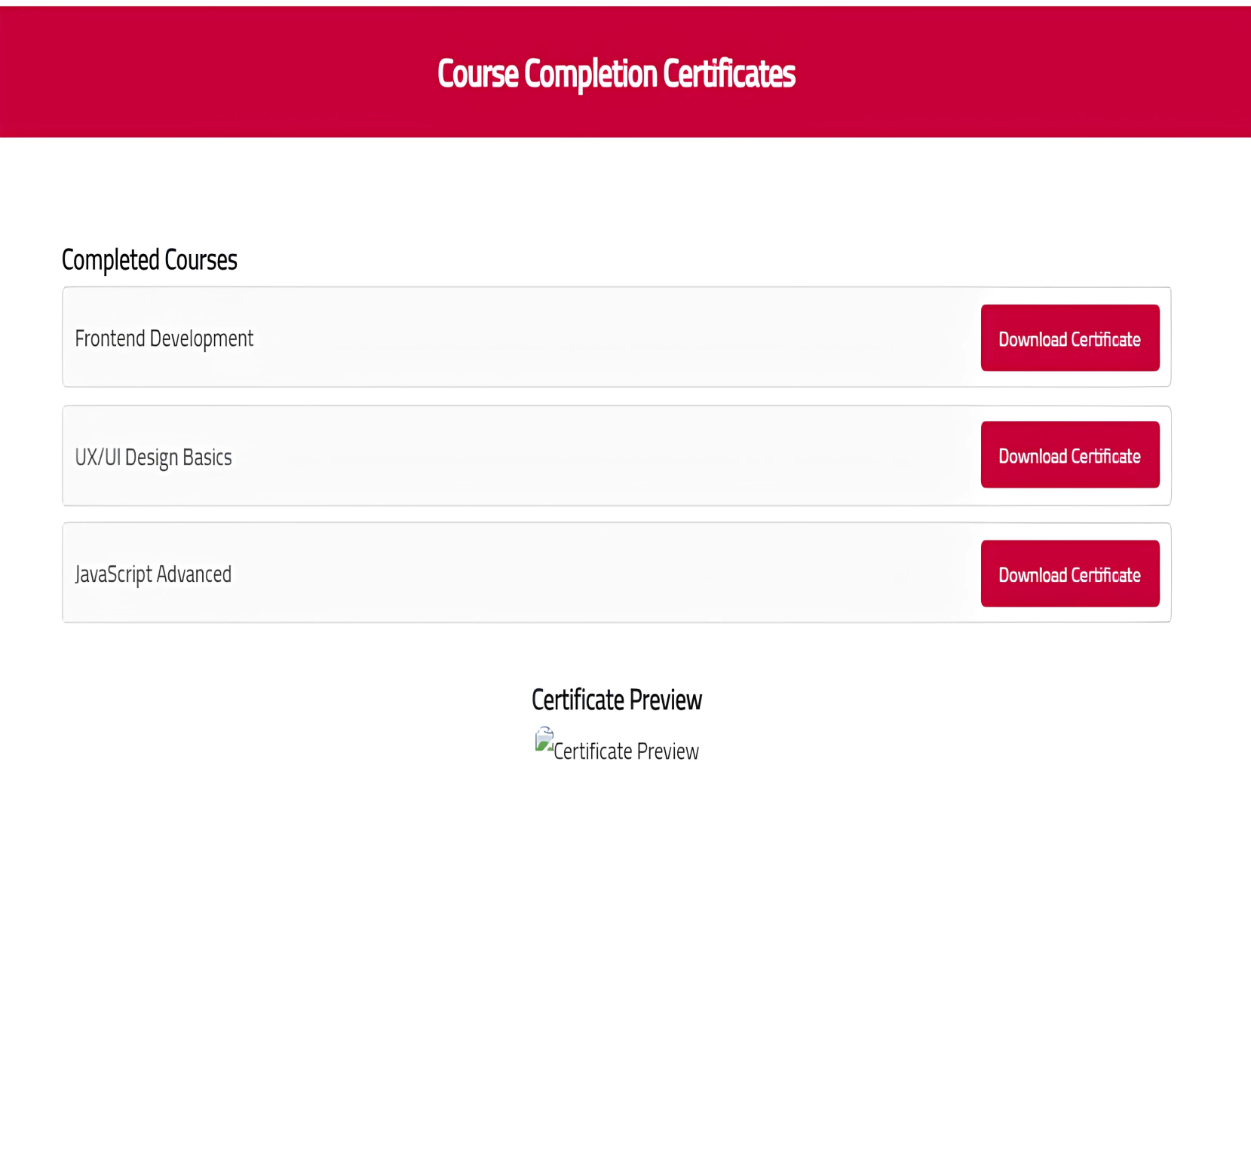

**3.5.10 Feedback&Evaluation :**

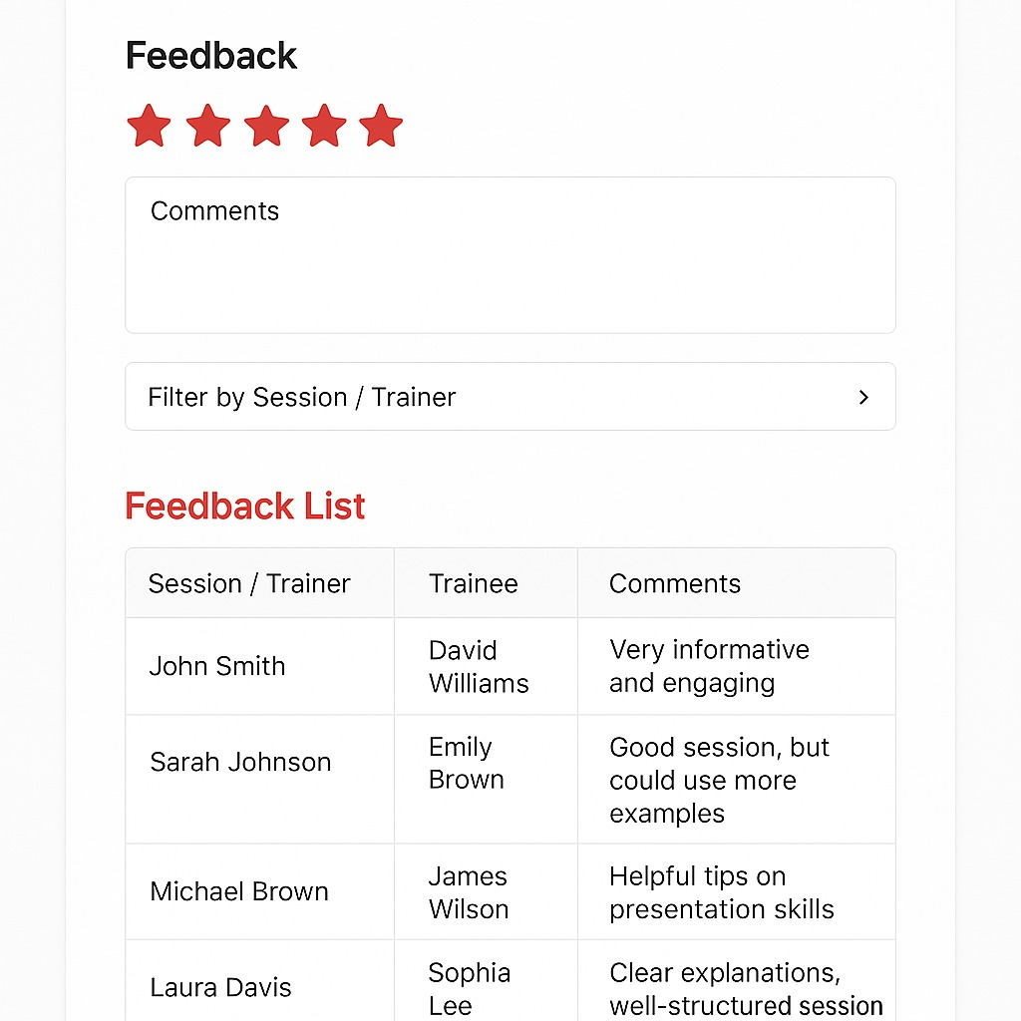

**3.5.11 Trainer Profile:**

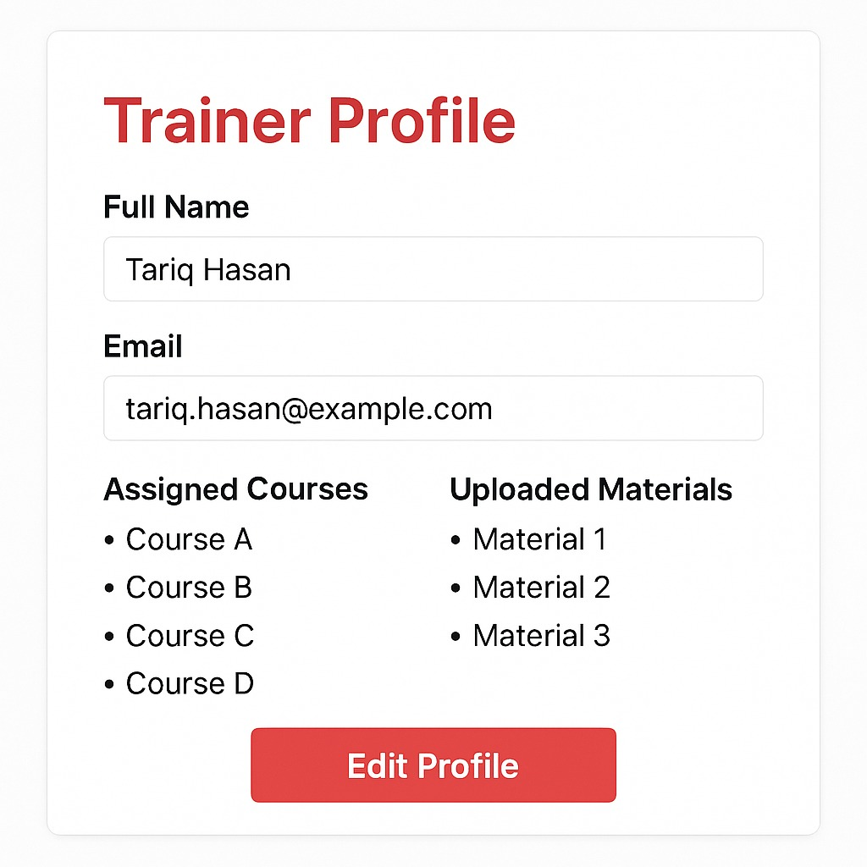

**3.5.12 Reports:**

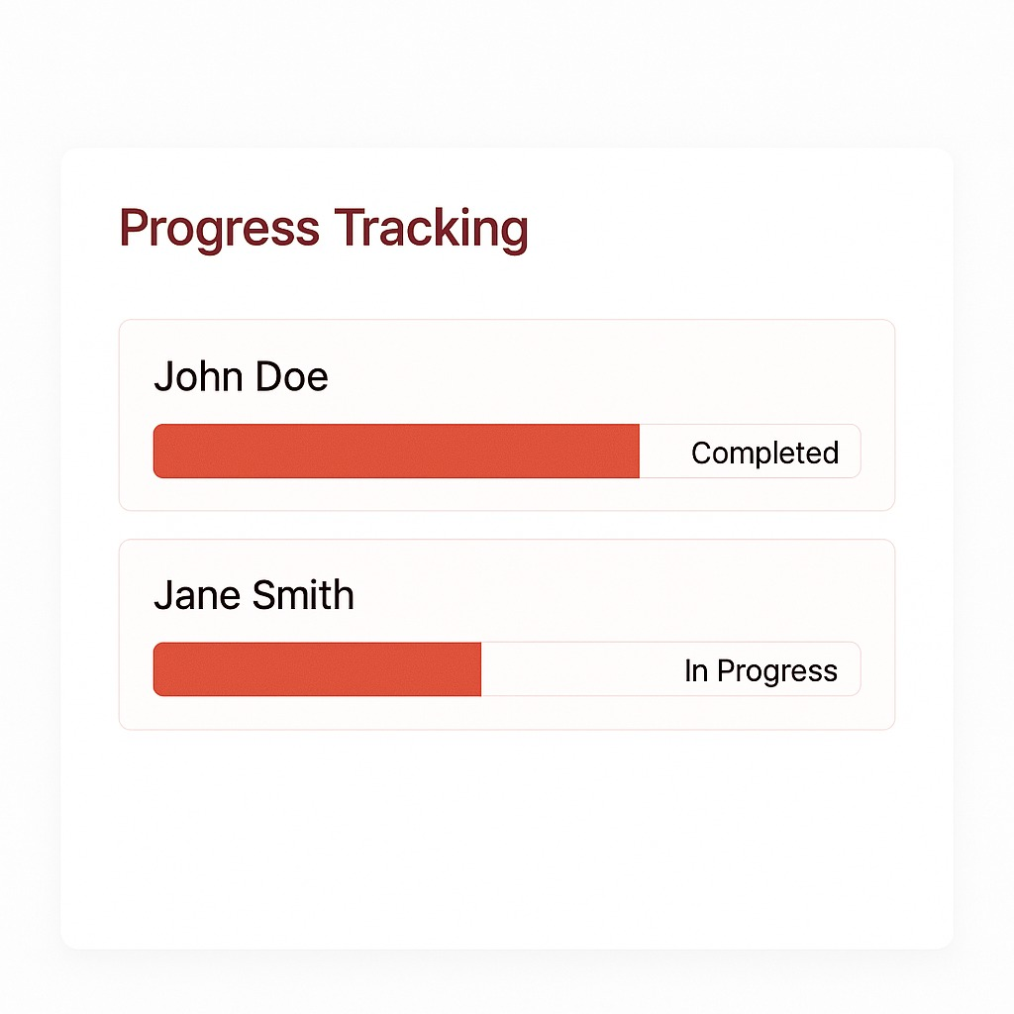

**3.5.13 Trainee Profile:**

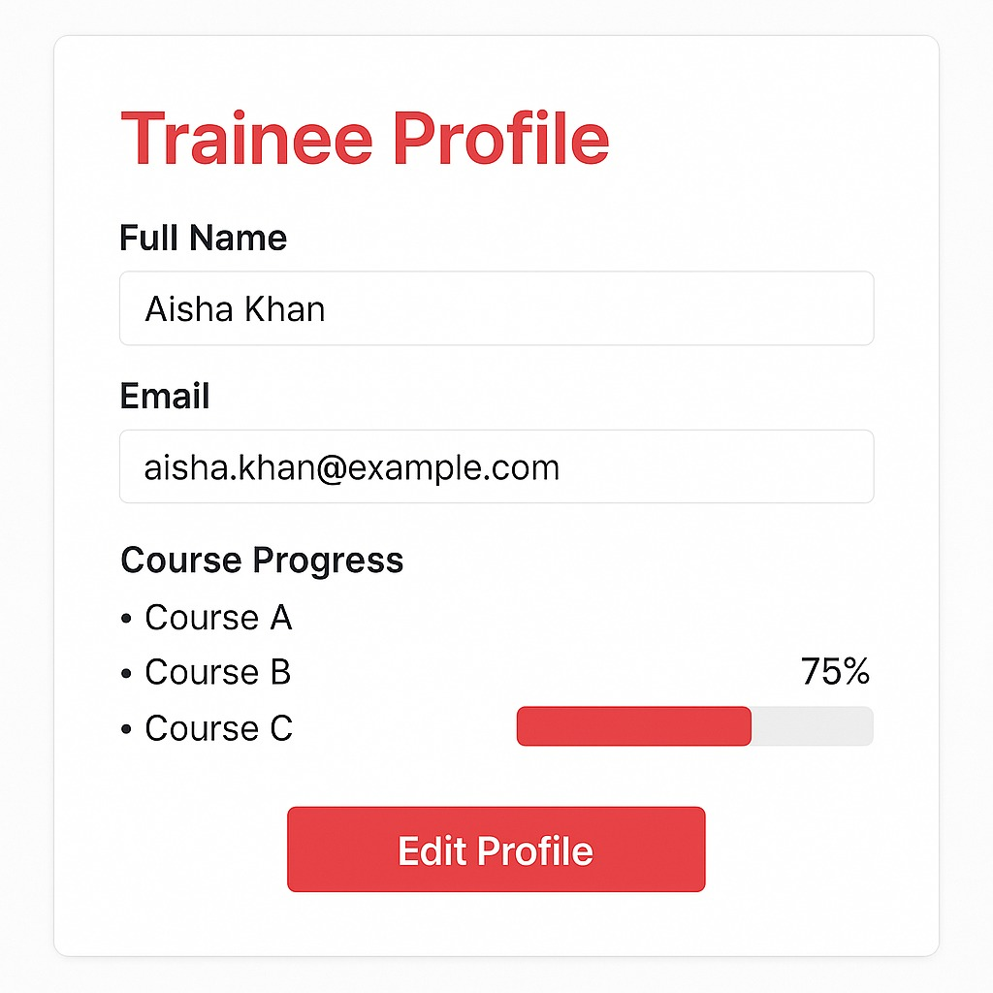

**3.5.14 Change password:**

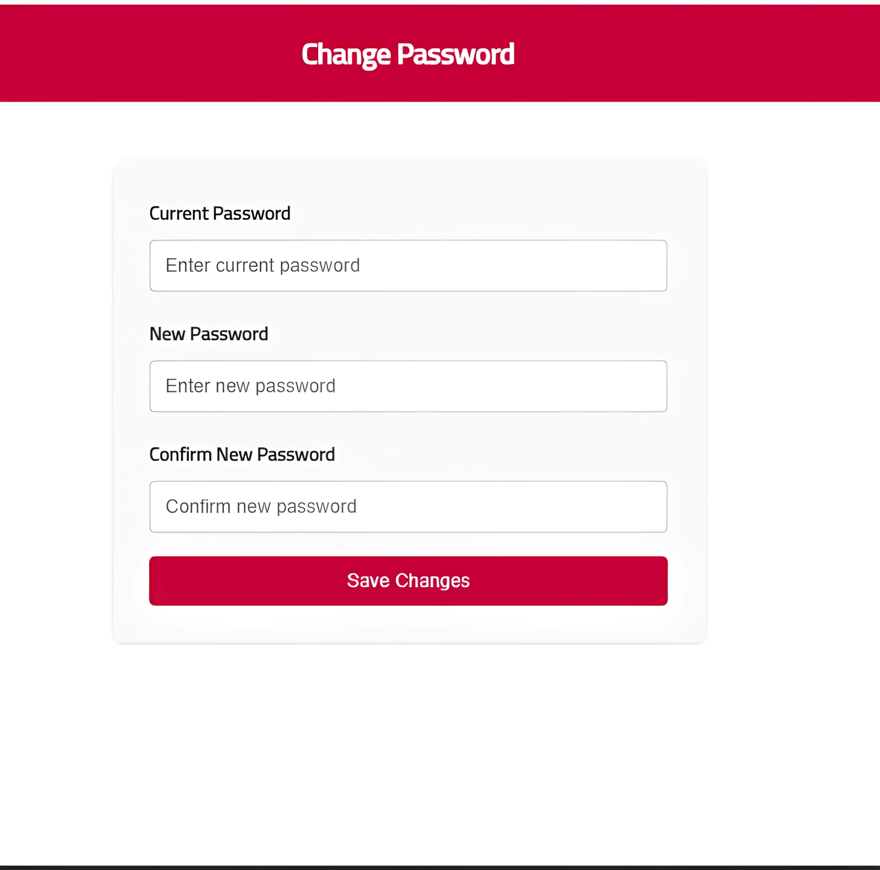

**3.5.15 Calender View:**

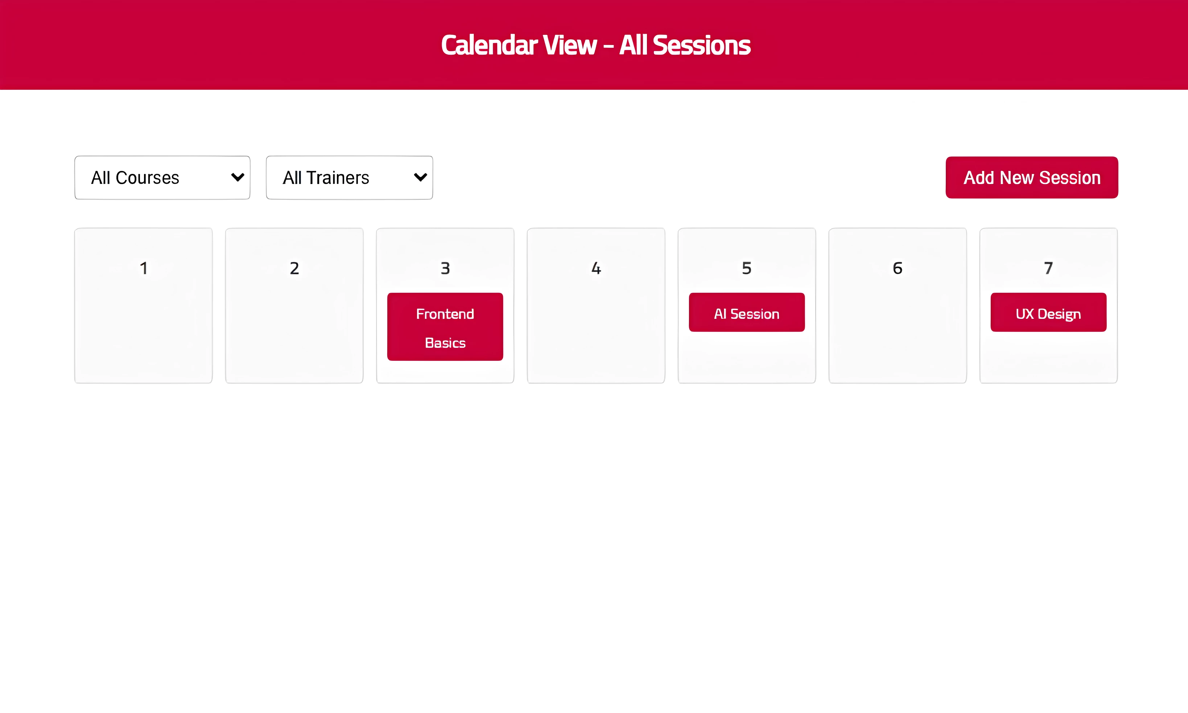

**3.5.16 Admin Settings:**

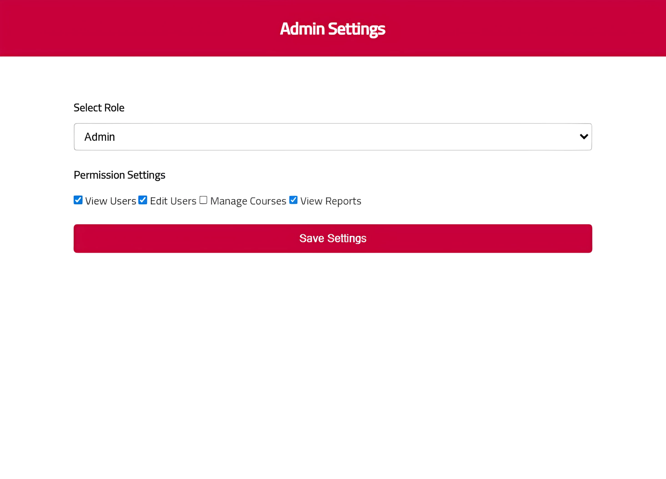

**3.5.17 Session Detail:**

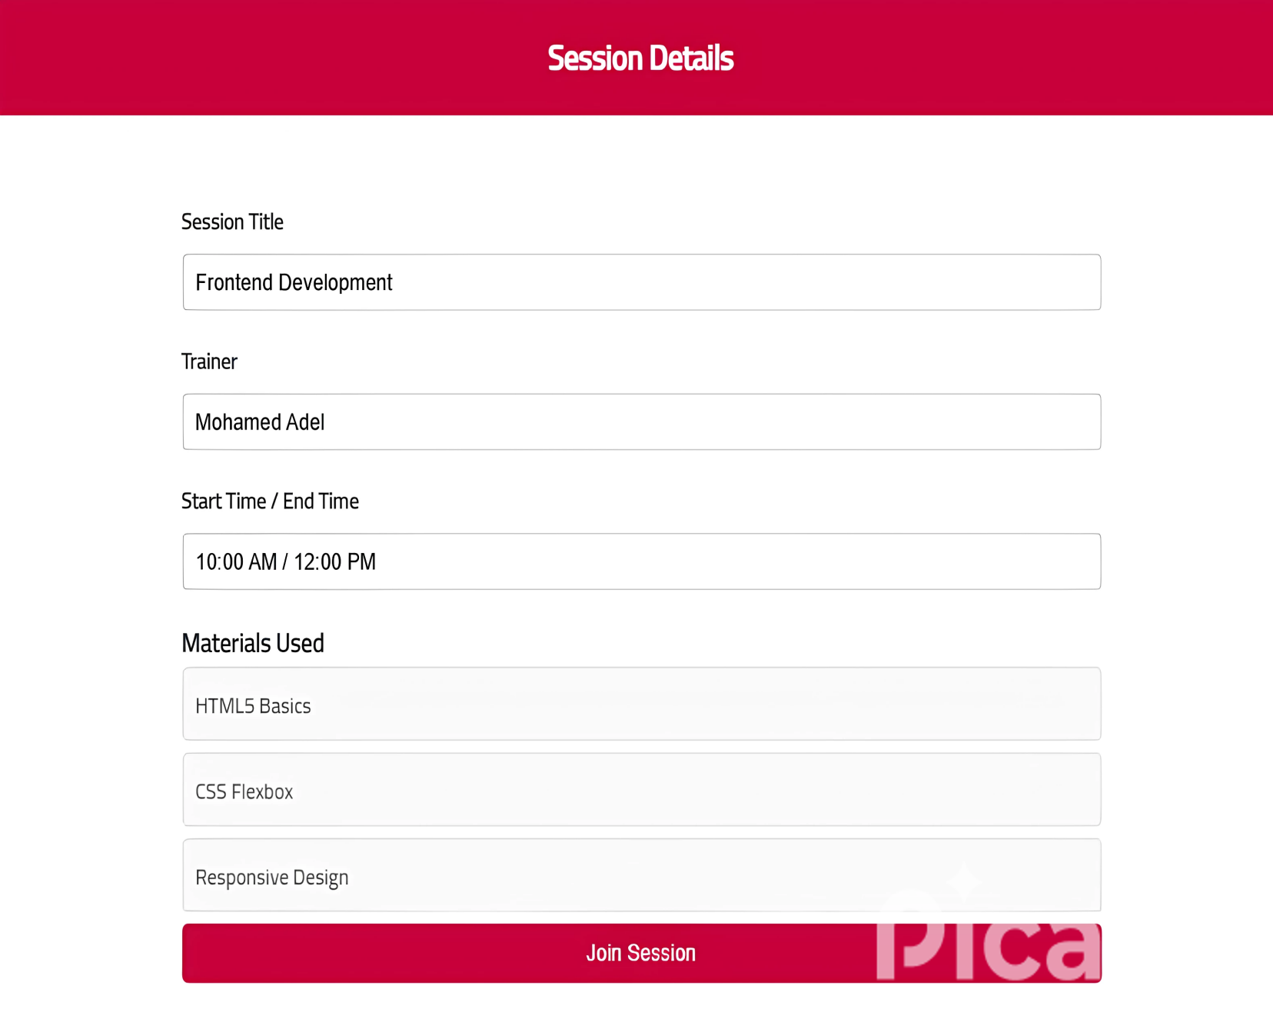

**3.5.18 Notifications Center:**

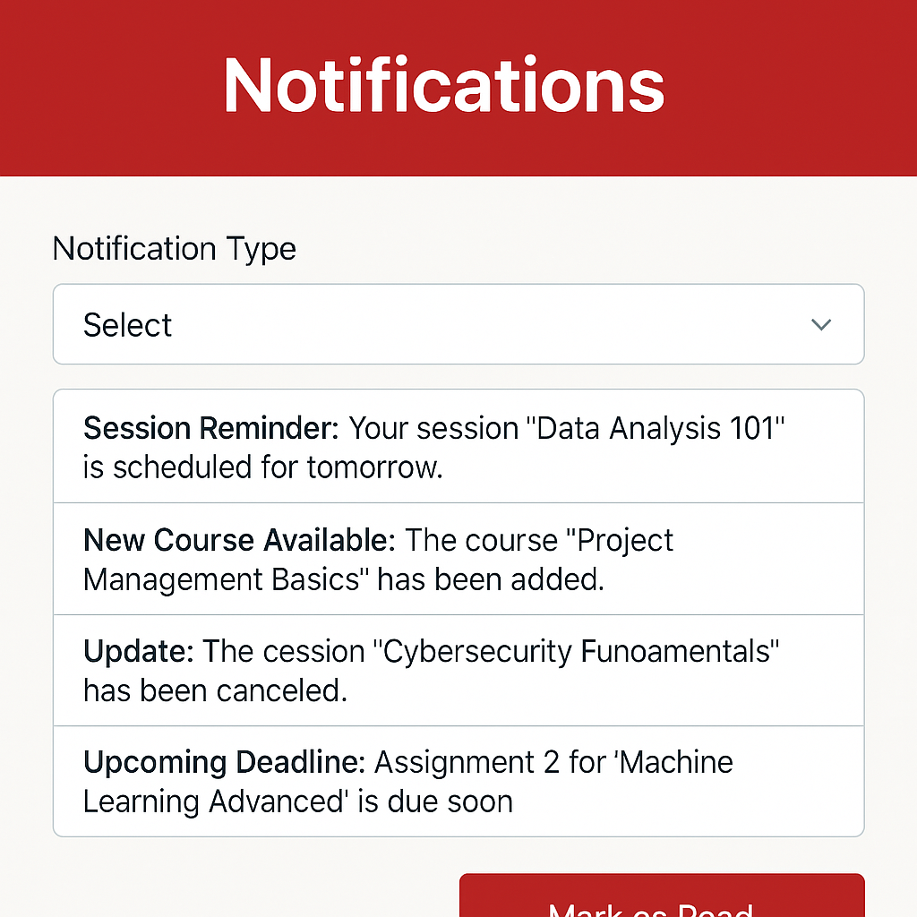

**3.5.19 Certificates:**

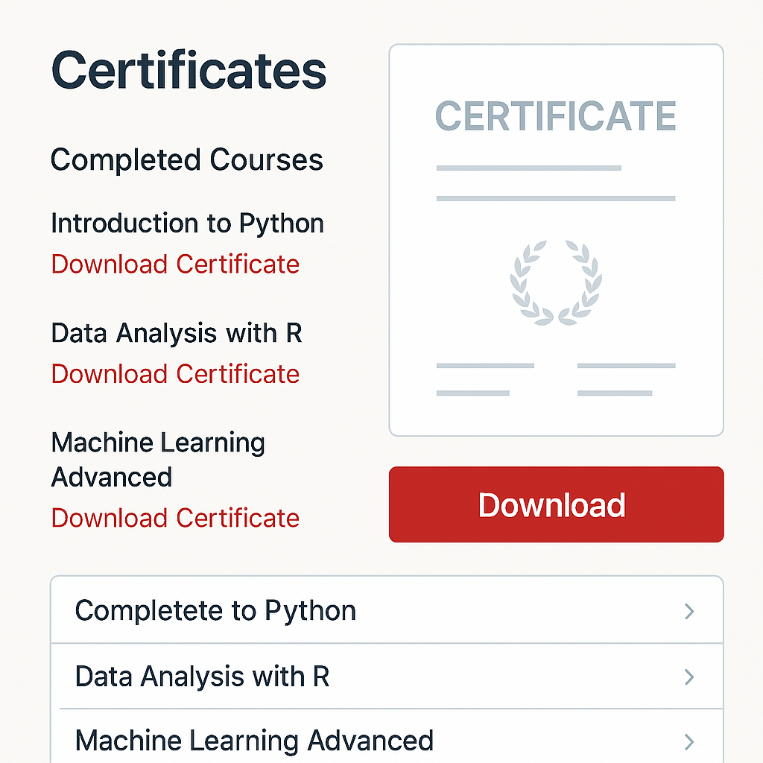



**Chapter 4**

**Future Work**

**4.1 FUTURE WORK:**



**Chapter 5**

**Conclusion**

**5.1 CONCLUSION:**

In conclusion, a Training Management System (TMS) is a powerful tool for optimizing training processes, from trainee enrollment to performance evaluation. By implementing this system, organizations can achieve the following:

Streamlined Operations: Efficiently manage trainee data, tasks, and progress tracking.

Enhanced User Experience: Provide an intuitive interface for trainers and trainees to access training content seamlessly.

Data-Driven Decisions: Leverage reports and analytics to refine training programs based on real-time performance insights.

Improved Engagement: Facilitate better communication and collaboration between instructors and trainees through integrated tools.

In summary, a TMS serves as an all-in-one solution to transform training from a routine task into a dynamic, results-driven experience—enhancing workforce skills and driving organizational growth.